Science  Materials and Matter  End Points:  - Everyday materials include wood, metal, plastic, glass, brick, rock, paper and cardboard.  - Every material has its own properties – these can include being hard, soft, opaque, shiny, bendy.  - Materials are used for a purpose depending on their properties.  Astronomy  End Points:  - The Sun is a star at the centre of our solar system.  - There are eight planets in our solar system: Mercury, Venus, Earth, Mars, Jupiter, Saturn, Uranus and Neptune.  - Planets travel (orbit) around the Sun.  - As the planets orbit the Sun, they also spin around (rotation). | History  The Tudors  - Key end points of ‘The Tudors’ unit are:  - Life was different for the rich and the poor in Tudor England  - Henry VII was the first Tudor monarch.  - Henry VIII made himself Head of the Church of England and had six wives.  - Edward VI was a Protestant and made religious reforms during his short reign.  - Mary I was a Catholic and is sometimes remembered as ‘Bloody Mary’.  - Elizabeth I reigned for 44 years. Her reign is sometimes remembered as the Golden Age. | Geography  Northern Europe  Key end points of this unit, Northern Europe are:  - The location of northern Europe means it has quite warm summers and very cold winters.  - Denmark, Norway and Sweden are Scandinavian countries.  - People and animals have adapted to survive the cold winters in Northern Europe.  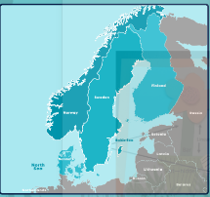  Within this unit children will use maps of Northern Europe to identify key countries and key physical features. They will use maps to explore the location of countries such as Denmark, Norway and Sweden.
Maths  - Addition and subtraction of 2 digit numbers.  - Money  - Faces, shapes and patterns; lines and turns  - Numbers within 1000  - Measures: Capacity and volume  Maths meetings will take place three times a week.  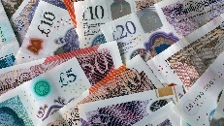  On Fridays, we will also complete weekly times tables tests. | Year 2 Maple and Willow Class  Summer  2024 | English  We will be looking at a range of stories including:  - Dish and Spoon  - The Twits  - Twelfth Night  In Poetry, we are focusing on:  Narrative, nonsense, and logic poems.  In Spelling, we are focusing on:  Adding suffixes where there are changes and no changes to root words.
RE  Multifaith leaders and teachers  This unit is a multifaith unit which will draw upon concepts in religion. This unit will aim to learn from the religious concept of leadership. Religious viewpoints that will be included in these series of lessons are: Judaism, Christianity, Islam, non-religious views.  Symbols and artefacts  This unit will aim to learn from the symbolism used in religion. This unit will also introduce the concept of an artefact starting at looking at religious artefacts such as the Cross and sacred texts. | Art  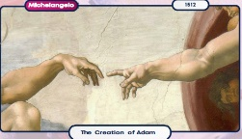  History Painting  The children make a study of the work of Picasso which show the minotaur and create their own work in mixed media.  Murals and Tapestries  Whilst studying murals and tapestries the children build a large work together. They aim to make an underwater sea scene by using monoprinting techniques and made by weaving. | Computing  Creating and using spreadsheet.
Design Technology
Moving Pictures
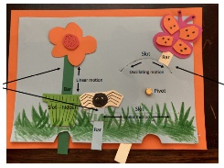
Creating a moving picture for a family member or a friend which operates using levers and sliders.
Music  Storm in Sound  Musical Focus Representation using sound Texture —layering sound (Rhythm—Ostinato rhythm shown with stick notation)  Lullabies  Musical Focus Lullabies—how music effects the way we feel Different qualities of the voice—including pitch, percussive quality, whispering (Articulation—sustained v staccato) | PE  - Net and wall  - Invasion games  - Striking and fielding  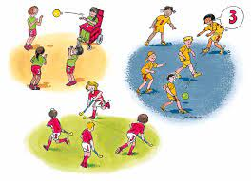  - Athletics | PSHE  Theme - Being Responsible  - Practice makes perfect  Theme – Our World  - Working in our world  Fire safety  - Petty arson

