English  Writing  - Gun Powder Plot (Newspaper Report)  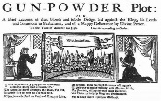  - This is London  (Persuasive Letter)  - On Sudden Hill  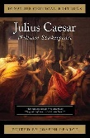  (Book Review)  - Julius Caesar (Shakespeare)  - Samuel Pepys (Diary Entry)  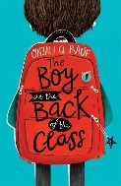  Reading  - The Boy at the Back of the Class  - Rumaysa by Radiya Hafiza | Maths  - Decimals  - Area and Perimeter  - Solving Measure  - Money Problems  - Shape and Symmetry  - Position and Direction  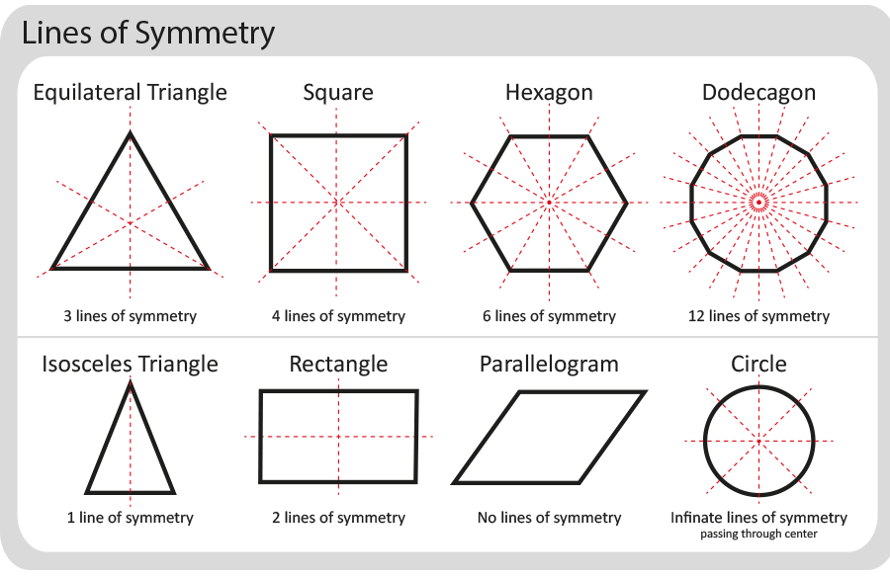  - Reasoning with Patterns and Sequences | Science  States of Matter and the Water Cycle  - The 3 states of matter are; solids, liquids and gases  - Water exists in all 3 states of matter  - How clouds are formed  Electricity  - An electrical circuit is a loop that allows electricity to travel around it  - Opening a circuit prevents electricity from flowing  - What are conductors and insulators
Art and Design  Monuments of the Byzantine Empire  - Hagia Sofia  - Mosaic  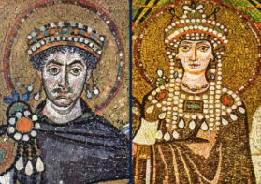 | YEAR 4  Curriculum Overview  Hazel, Cedar, Ash  Summer term 2024 | RE  Multifaith Right, Wrong and Rules  - Five Pillars of Islam  - The 10 Commandments  - 5Ks of Sikhism  - The Golden Rule  Multifaith Sacrifice  - What a sacrifice is  - Pilgrimage of a sacrifice  - Fasting as a sacrifice
History  The Stuarts  - Stuart kings and queens  - Oliver Cromwell  - Gun Powder Plot  - Great Fire of London  - Bill of Rights  - Significant British Architecture  - Monarchy, law, religion and war |  | Geography  London and the South East  - London is located in the South East of England  - The Roman’s built London as a useful port for trading  - Canterbury is a historical place with a rich history  Asia  - Japan has a varied climate  - Japan is located in the Northern Hemisphere in the continent of Asia  - Japan is made up of four main islands and many smaller islands  - Japan has many cities, including Tokyo and Kyoto
French  - En Classe (In the Classroom)  - Les Jeux Olympiques (Olympics) | Computing  We will cover the Purple Mash units:  - Coding  - Spreadsheets  - Writing for different audiences | Design and Technology  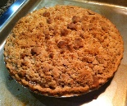  - Cooking –  Making apple crumble
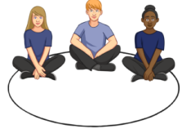  PSHE  - Jealousy  - Online Bullying  - Chores at home  - Breaking Down Barriers  - First Aid | Music  - Stories in Sound  - Announcing an Entrance | 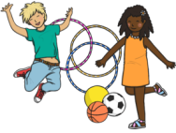  PE  - Athletics and Cricket  - Tennis and Rounders  Please ensure that the children have a PE kit suitable for outdoor and indoor lessons. Our PE days are Tuesdays and Thursdays.

