English  Writing  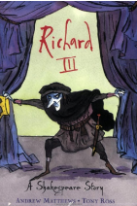  - Plants (Explanation Text)  - Peter Pan (Narrative)  - On Sudden Hill (Book Review)  - A Night at the Museum (Suspense Narrative)  - Richard III (Character Analysis)  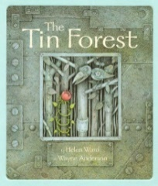  Reading  - Culture of Clothes and The Proudest Blue  - The Tin Forest  - Folk Tales  - Mythopedia  - Animal Sidekicks | Maths  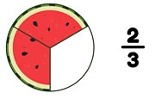  - Fractions  - Tenths  - Add and subtract fractions  - Equivalent fractions  - Fraction of a number  - Angles and Shapes  - 2D and 3D shapes  - Angles and turns  - Right angles  - Horizontal, vertical, perpendicular and parallel lines  - Measures  - measure, compare, add and subtract: lengths (m/cm/mm); mass (kg/g); volume/capacity (l/ml)  - Applying multiplicative thinking  - Exploring calculation strategies and place value | Science  Rocks  - Rocks have different names and can be sorted into groups according to their properties  - There are three main groups of rock called sedimentary, igneous and metamorphic  - Fossils are formed when rock forms around things that once lived  - Fossils are rare and take thousands of years to form  Forces and Magnets  - A force is a push or a pull.  - Gravity is a force that makes objects fall to the ground.  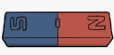  - Friction is the force between two surfaces.  - A magnet has two opposite poles: the north and south pole.
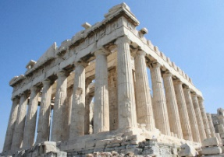  Art and Design  Architecture  - Study of the Parthenon contrasts with focus on the work of Gaudi  - learn how his designs were influenced by nature and were extraordinary for their time because of his use of curved lines and organic shapes.  Modern Architecture  - Make their own models and undertake an experiment to explore the physics behind the construction of the tallest bridge in the world, the Millau Viaduct. | YEAR 3  Curriculum Overview  Elder and Sycamore  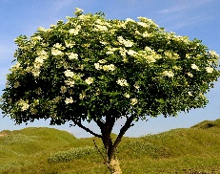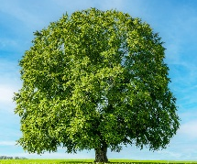  Summer term 2024 | RE  Multifaith Religion in our local community  - Religions in UK – diversity  - Religions and denominations in our local area  - Places of worship in our local area – Christian churches  - Places of worship in our local area – place worship different religion  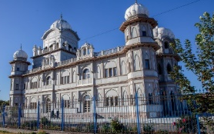  - Similarities between different religions
History  Law and Power  - To know that a big misunderstanding between Henry II and Thomas Becket  - To understand why King John was forced agree to demands from the barons and seal the Magna Carta  - To know that Simon de Montfort set up the first Parliament  Wars of the Roses  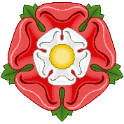  - The Wars of the Roses was a civil war fought between 1455 and 1485 between two families for the English throne- the House of York and the House of Lancaster.  - Henry Tudor was a Lancastrian and married Elizabeth of York. This ended the Wars of the Roses. |  | Geography  Western Europe  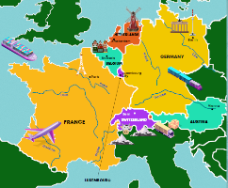  - The countries in Western Europe include; France, Germany, the Netherlands, Belgium, Switzerland, Luxembourg and Austria.  - Western Europe has a temperate climate which means it doesn’t get extremely hot or cold.  Asia: India and China  - To know the physical and human features of India.  - To know the physical and human features of China.  - To compare India and China
French  - Les Animaux (Animals)  - Les Glaces (Ice Creams) | Computing  We will cover the Purple Mash units:  - Graphing  - Simulations  - E-mail | 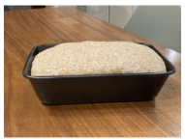  Design and Technology  - Cookery –Making bread and butter from scratch.
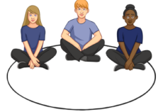  PSHE  - Computer Safety  - Keeping safe  - Fire Safety  - Our World | Music  - Singing games  - Compositions | PE  - Handball and Golf  - Athletics and Tennis  Please ensure that the children have a PE kit suitable for outdoor and indoor lessons. Our PE days are Mondays and Wednesdays.

