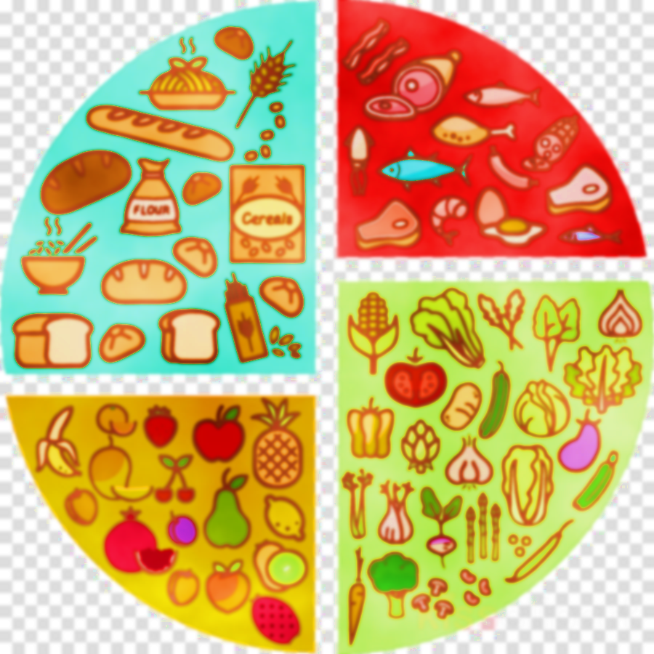  WEEK 3 | MONDAY | TUESDAY | WEDNESDAY | THURSDAY | FRIDAY
MEAT | BEEF BOLOGNAISE WITH PASTA | SWEET AND SOUR CHICKEN WITH NOODLES | ROAST GAMMON WITH ROAST POTATOES | SALMON FISHCAKE WITH WEDGES | PORK SAUSAGE WITH CHIPS
VEGGIE OPTION | CHEESE AND ONION PASTY WITH NEW POTATOES | MACARONI CHEESE WITH GARLIC BREAD | ROAST QUORN WITH ROAST POTATOES | CHEESE AND TOMATO PIZZA WITH WEDGES | VEGGIE SAUSAGES WITH CHIPS
JACKET FILLING | BAKED BEANS & CHEESE | BEEF CHILLI | GRATED CHEESE | COLESLAW | BAKED BEANS & CHEESE
VEGGIES | BAKED BEANS OR SWEETCORN | PEAS OR GREEN BEANS | CARROTS OR CAULIFLOWER | SWEETCORN OR BROCCOLI | BAKED BEANS OR PEAS
DESSERT | ICED SPONGE WITH CREAM | BLUEBERRY MUFFIN | CHOCOLATE MOUSSE CAKE | BANANA CAKE WITH TOFFEE CUSTARD | CHOCOLATE COCONUT COOKIES
PACKED LUNCH | TURKEY SANDWICH OR CHEESE TOMATO ROLL | BLT ROLL OR EGG MAYO SANDWICH | PORK SAUSAGE ROLL OR CHEESE SANDWICH | CHICKEN TIKKA SANDWICH OR CHEESE SALAD WRAP | PEPPERONI & CHEESE ROLL OR VEG COUS COUS
W/C 2ND MAY, 23RD MAY, 13TH JUNE, 4TH JULY

