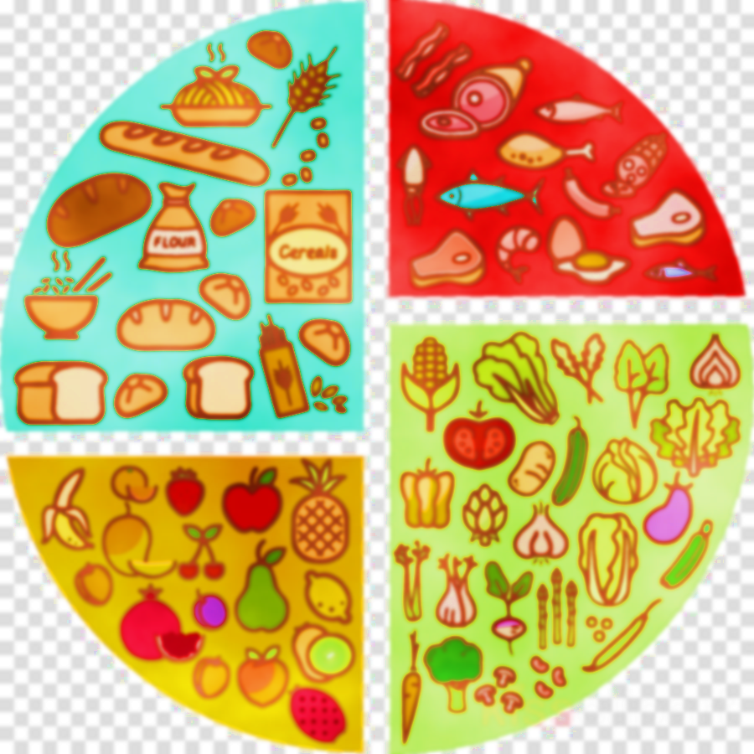  WEEK 2 | MONDAY | TUESDAY | WEDNESDAY | THURSDAY | FRIDAY
MEAT | PORK SAUSAGE ROLL WITH HERBY DICED POTATOES | MINCE BEEF AND MUSHROOM PIE WITH WEDGES | CHICKEN SAUSAGES AND ROAST POTATOES | BEEF CHILLI CON CARNE WITH RICE | CHICKEN NUGGETS WITH CHIPS
VEGGIE OPTION | VEGETABLE CURRY WITH RICE | CHEESE & TOMATO PIZZA WITH WEDGES | (v) SAUSAGE & BEAN CASSEROLE & ROASTS | MACARONI CHEESE WITH GARLIC BREAD | VEGETABLE RAVIOLI
JACKET FILLING | BEANS AND CHEESE | COLESLAW | TUNA & MAYO | HAM AND CHEESE | BEANS & CHEESE
VEGGIES | MIXED SALAD OR SWEETCORN | BAKED BEANS OR BROCCOLI | CARROTS OR CABBAGE | SWEETCORN OR PEAS | BAKED BEANS OR MIXED VEGETABLES
DESSERT | APPLE CRUMBLE AND CUSTARD | VANILLA CHEESECAKE | CHOCOLATE RASPBERRY BROWNIE | STICKY TOFFEE PUDDING AND CUSTARD | FLAPJACK
PACKED LUNCH | HAM ROLL OR CHEESE AND TOMATO WRAP | TURKEY ROLL OR CHEESE & ONION MAYO SANDWICH | HAM SANDWICH OR CHEESE ROLL | BBQ CHICKEN ROLL OR JAM SANDWICH | BLT ROLL OR FALAFEL WRAP
W/C 25TH APRIL, 16TH MAY, 6TH JUNE, 27TH JUNE, 18TH JULY

