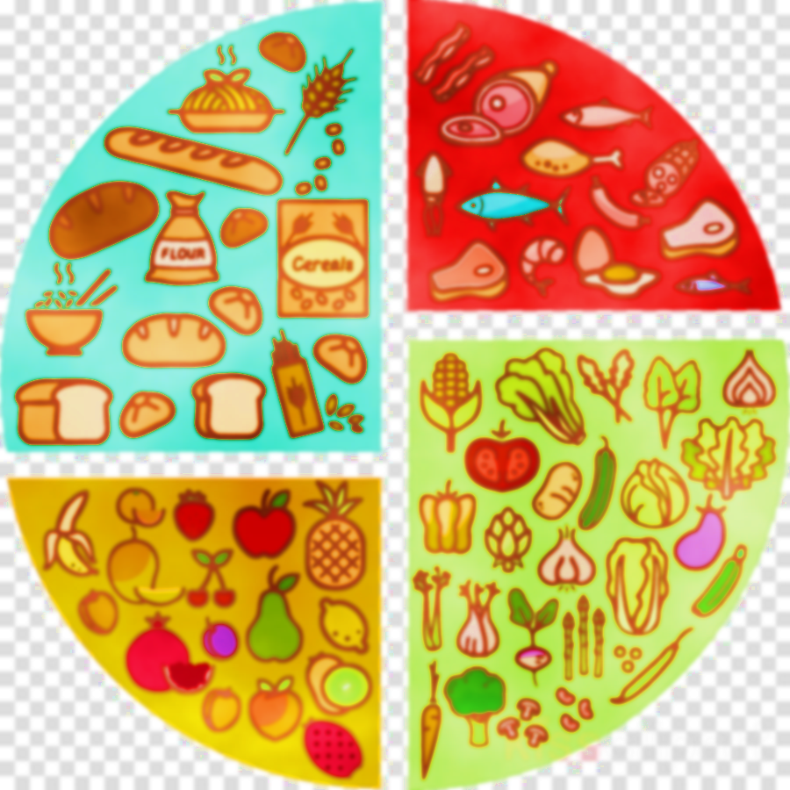  WEEK 1 | MONDAY | TUESDAY | WEDNESDAY | THURSDAY | FRIDAY
MEAT | PORK MEATBALLS IN TOMATO SAUCE & PASTA | TERIYAKI CHICKEN WITH BABY CORN AND RICE | ROAST PORK, GRAVY & ROAST POTATOES | CHICKEN TIKKA MASALA WITH PILAU RICE | FISH FINGERS AND CHIPS
VEGGIE OPTION | VEGETABLE NUGGETS & PASTA | MACARONI CHEESE WITH GARLIC BREAD | CREAMY VEGETABLE PIE & ROAST POTATOES | CHEESE AND TOMATO PIZZA WITH WEDGES | ROASTED VEGETABLE GNOCCHI
JACKET FILLING | GRATED CHEESE | TUNA MAYO | COLESLAW | GRATED CHEESE | BEANS & CHEESE
VEGGIES | SWEETCORN OR GREEN BEANS | PEAS OR MIXED SALAD | SLICED CARROTS OR BROCCOLI | PEAS OR SWEETCORN | BAKED BEANS OR BABY CORN
DESSERT | APPLE & CHERRY PIE & ICECREAM | CHOCOLATE FUDGE CAKE WITH CHOC SAUCE | CHOCOLATE SHORTBREAD | CARROT CAKE WITH VANILLA FROSTING | OAT COOKIE
PACKED LUNCH | TUNA MAYO SANDWICH OR CHEESE ROLL | CHICKEN SALAD WRAP OR TOMATO PASTA | HAM ROLL OR JAM SANDWICH | PORK SAUSAGE ROLL OR EGG SANDWICH | HAM ROLL OR CHEESE & ONION  SANDWICH
W/C 18TH APRIL, 9TH MAY, 30TH MAY, 20TH JUNE, 11TH JULY

